1. 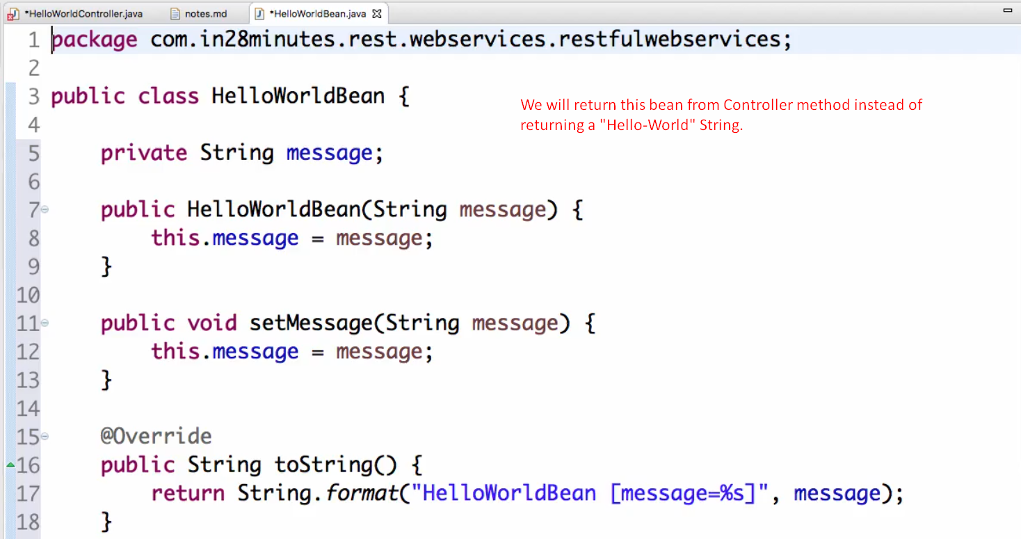
2. 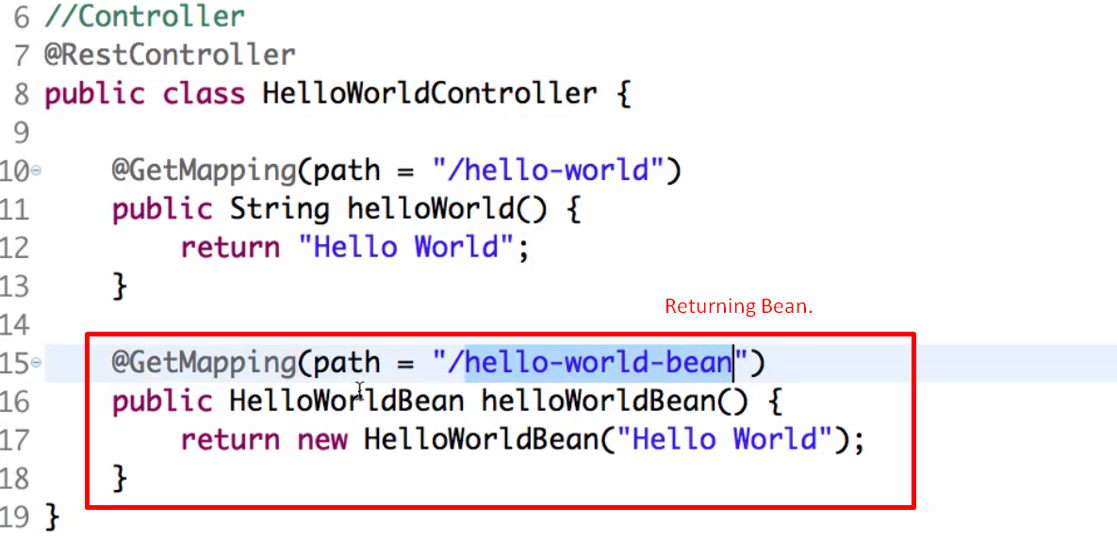
3. 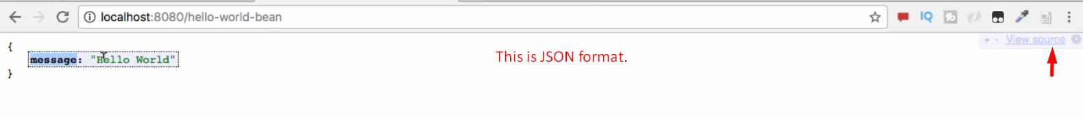
4. This bean is converted into JSON format due to @RestController annotation on the controller class.